ADD NEW Staff-Patient Relationship to Staff_Patients Page

ADD NEW Staff-Patient Relationship to Staff_Patients Through Update Staff In UPDATE Order Page

DISPLAY All Staff_Patients Relationship Page

UPDATE Staff-Patient Relationship in Staff_Patients Page (Pre-Update)

UPDATE Staff-Patient Relationship in Staff_Patients Page (During-Update)

UPDATE Staff-Patient Relationship in Staff_Patients Page (Post-Update)

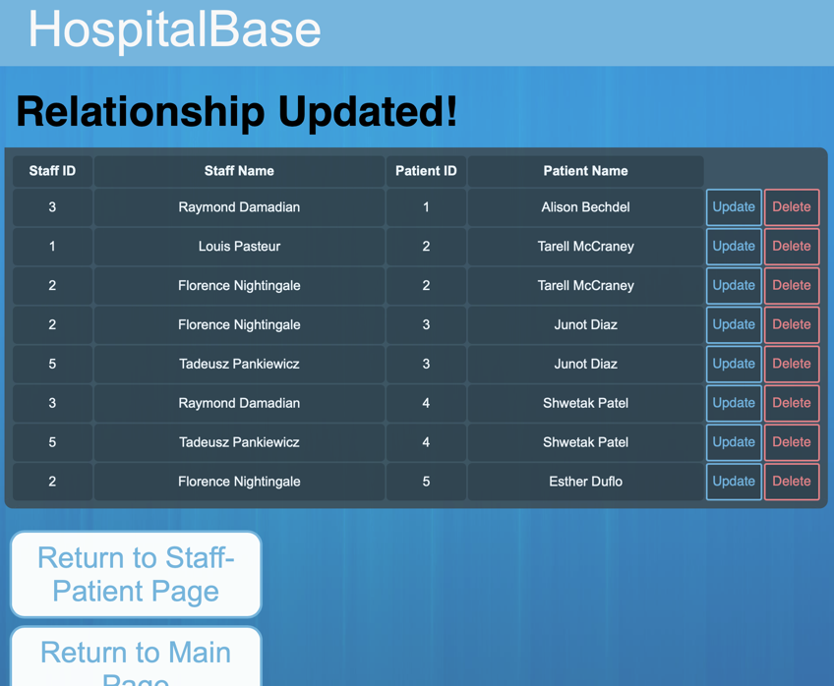

DELTE Staff-Patient Relationship in Staff_Patients Page (Pre-Delete)

DELTE Staff-Patient Relationship in Staff_Patients Page (Post-Delete)

